**G pavan kumar**

**916217**

**Stage 3 - Angular - Day 71 – Hands on**

**Create Component and Display Employee List**

**emp-info.component.ts**

import { Component, Input} from '@angular/core';

import { ActivatedRoute } from '@angular/router';

@Component({

  selector: 'app-emp-info',

  templateUrl: './emp-info.component.html'

})

export class EmpInfoComponent {

  empObj :any={};

  @Input() employee = [{id:1, name:"John", salary:5000, permanent:true, department:[{id:3, name:"Payroll"}],skills:[{id:1, name:"HTML"}] },

  {id:2, name:"Smith", salary:10000, permanent:true, department:[{id:6, name:"Internal"}],skills:[{id:2, name:"JAVA"}] },

  {id:3, name:"Mary", salary:55000, permanent:true, department:[{id:2, name:"Lead"}],skills:[{id:1, name:"HTML"}] },

  {id:4, name:"Sandy", salary:15000, permanent:true, department:[{id:3, name:"Payroll"}],skills:[{id:3, name:"CSS"}] },

  {id:5, name:"Martin", salary:20000, permanent:true, department:[{id:2, name:"Lead"}],skills:[{id:1, name:"HTML"}] }

]

  constructor(private route:ActivatedRoute)

  {

      let eno  =  this.route.snapshot.params["id"];

      this.empObj = this.employee.find(  item => item.id == eno );

  }

}

interface Department{

  id:number;

  name:string;

}

 interface Skill{

  id:number;

  name:string;

}

 interface Employee extends Department, Skill{

  id:number;

  name:string;

  salary:number;

  permanent:boolean;

  department:Department[];

  skills:Skill[];

}

**emp-info.component.html**

<h2>Employee Details</h2>

<div class="cardblock">

    <br>

    Name : {{empObj.name}}

    <br>

    <br>

    Salary : {{empObj.salary | currency : "INR"}}

    <br>

    <br>

    Permanent : {{empObj.permanent}}

    <br>

    <br>

    <a class="editLink" [routerLink]="['/edit-emp-reactive',empObj.id]">Edit</a>

</div>

**employee-list.component.ts**

import { Component, Output, OnInit} from '@angular/core';

import { ActivatedRoute } from "@angular/router";

@Component({

  selector: 'app-employee-list',

  templateUrl: './employee-list.component.html'

})

export class EmployeeListComponent implements OnInit{

   employeeList:Employee[]=[];

ngOnInit(){

  this.employeeList = [{id:1, name:"John", salary:5000, permanent:true, department:[{id:3, name:"Payroll"}],skills:[{id:1, name:"HTML"}] },

  {id:2, name:"Smith", salary:10000, permanent:true, department:[{id:6, name:"Internal"}],skills:[{id:2, name:"JAVA"}] },

  {id:3, name:"Mary", salary:55000, permanent:true, department:[{id:2, name:"Lead"}],skills:[{id:1, name:"HTML"}] },

  {id:4, name:"Sandy", salary:15000, permanent:true, department:[{id:3, name:"Payroll"}],skills:[{id:3, name:"CSS"}] },

  {id:5, name:"Martin", salary:20000, permanent:true, department:[{id:2, name:"Lead"}],skills:[{id:1, name:"HTML"}] }

]

}

public searchKey:string="";

Search()

{

  if(this.searchKey != "")

  {

    this.employeeList = this.employeeList.filter(res=>{

      return res.name.toLocaleLowerCase().match(this.searchKey.toLocaleLowerCase());

});

  }

  else if(this.searchKey == "")

  {

    this.ngOnInit();

  }

}

}

 interface Department{

  id:number;

  name:string;

}

 interface Skill{

  id:number;

  name:string;

}

 interface Employee extends Department, Skill{

  id:number;

  name:string;

  salary:number;

  permanent:boolean;

  department:Department[];

  skills:Skill[];

}

**employee-list.componen.html**

<h3>Employee List</h3>

<div style="margin: 20px;">

    Search &nbsp;

    <input type="text" placeholder="Find by name" [(ngModel)]="searchKey"  (input)="Search()">

</div>

<div class="row">

<div class="container" *ngFor="let emp of employeeList">

<div class="column" style="padding:5px;">

    <div class="cardblock" style="width: 18rem;border: 2px solid #000000;border-color:#0645AD;padding:5px;">

        <span style="font-size: 30px;">{{emp.name}}</span>

        <br>

        {{emp.salary | currency : "INR"}}<br>

        <a class="editLink" [routerLink]="['/edit-emp-reactive',emp.id]">Edit</a>

    </div>

</div>

</div>

</div>

**Output:**

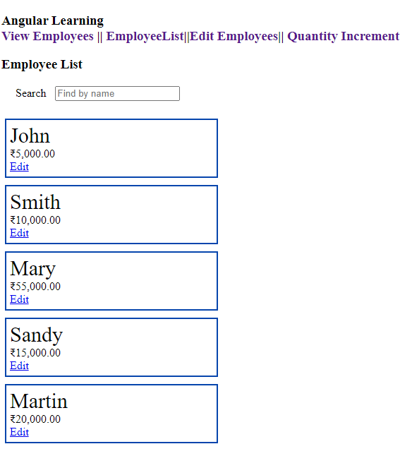

Create Master / Detail Component

**employee-list.component.ts**

import { Component, Output, OnInit} from '@angular/core';

import { ActivatedRoute } from "@angular/router";

@Component({

  selector: 'app-employee-list',

  templateUrl: './employee-list.component.html'

})

export class EmployeeListComponent implements OnInit{

   employeeList:Employee[]=[];

ngOnInit(){

  this.employeeList = [{id:1, name:"John", salary:5000, permanent:true, department:[{id:3, name:"Payroll"}],skills:[{id:1, name:"HTML"}] },

  {id:2, name:"Smith", salary:10000, permanent:true, department:[{id:6, name:"Internal"}],skills:[{id:2, name:"JAVA"}] },

  {id:3, name:"Mary", salary:55000, permanent:true, department:[{id:2, name:"Lead"}],skills:[{id:1, name:"HTML"}] },

  {id:4, name:"Sandy", salary:15000, permanent:true, department:[{id:3, name:"Payroll"}],skills:[{id:3, name:"CSS"}] },

  {id:5, name:"Martin", salary:20000, permanent:true, department:[{id:2, name:"Lead"}],skills:[{id:1, name:"HTML"}] }

]

}

public searchKey:string="";

Search()

{

  if(this.searchKey != "")

  {

    this.employeeList = this.employeeList.filter(res=>{

      return res.name.toLocaleLowerCase().match(this.searchKey.toLocaleLowerCase());

});

  }

  else if(this.searchKey == "")

  {

    this.ngOnInit();

  }

}

}

 interface Department{

  id:number;

  name:string;

}

 interface Skill{

  id:number;

  name:string;

}

 interface Employee extends Department, Skill{

  id:number;

  name:string;

  salary:number;

  permanent:boolean;

  department:Department[];

  skills:Skill[];

}

**employee-list.componen.html**

<h3>Employee List</h3>

<div style="margin: 20px;">

    Search &nbsp;

    <input type="text" placeholder="Find by name" [(ngModel)]="searchKey"  (input)="Search()">

</div>

<div class="row">

<div class="container" *ngFor="let emp of employeeList">

<div class="column" style="padding:5px;">

    <div class="cardblock" style="width: 18rem;border: 2px solid #000000;border-color:#0645AD;padding:5px;">

        <span style="font-size: 30px;">{{emp.name}}</span>

        <br>

        {{emp.salary | currency : "INR"}}<br>

        <a class="editLink" [routerLink]="['/edit-emp-reactive',emp.id]">Edit</a>

    </div>

</div>

</div>

</div>

**Output:**

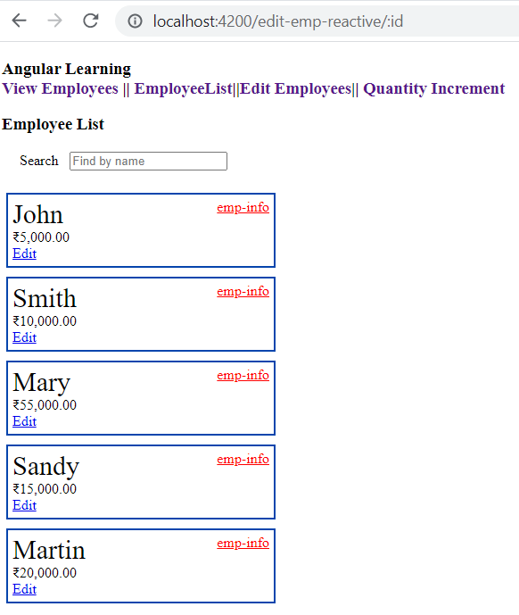

**Implement Search**

**employee-list.component.ts**

import { Component, Output, OnInit} from '@angular/core';

import { ActivatedRoute } from "@angular/router";

@Component({

  selector: 'app-employee-list',

  templateUrl: './employee-list.component.html'

})

export class EmployeeListComponent implements OnInit{

   employeeList:Employee[]=[];

ngOnInit(){

  this.employeeList = [{id:1, name:"John", salary:5000, permanent:true, department:[{id:3, name:"Payroll"}],skills:[{id:1, name:"HTML"}] },

  {id:2, name:"Smith", salary:10000, permanent:true, department:[{id:6, name:"Internal"}],skills:[{id:2, name:"JAVA"}] },

  {id:3, name:"Mary", salary:55000, permanent:true, department:[{id:2, name:"Lead"}],skills:[{id:1, name:"HTML"}] },

  {id:4, name:"Sandy", salary:15000, permanent:true, department:[{id:3, name:"Payroll"}],skills:[{id:3, name:"CSS"}] },

  {id:5, name:"Martin", salary:20000, permanent:true, department:[{id:2, name:"Lead"}],skills:[{id:1, name:"HTML"}] }

]

}

public searchKey:string="";

Search()

{

  if(this.searchKey != "")

  {

    this.employeeList = this.employeeList.filter(res=>{

      return res.name.toLocaleLowerCase().match(this.searchKey.toLocaleLowerCase());

});

  }

  else if(this.searchKey == "")

  {

    this.ngOnInit();

  }

}

}

 interface Department{

  id:number;

  name:string;

}

 interface Skill{

  id:number;

  name:string;

}

 interface Employee extends Department, Skill{

  id:number;

  name:string;

  salary:number;

  permanent:boolean;

  department:Department[];

  skills:Skill[];

}

**employee-list.componen.html**

<h3>Employee List</h3>

<div style="margin: 20px;">

    Search &nbsp;

    <input type="text" placeholder="Find by name" [(ngModel)]="searchKey"  (input)="Search()">

</div>

<div class="row">

<div class="container" *ngFor="let emp of employeeList">

<div class="column" style="padding:5px;">

    <div class="cardblock" style="width: 18rem;border: 2px solid #000000;border-color:#0645AD;padding:5px;">

        <span style="font-size: 30px;">{{emp.name}}</span>

        <br>

        {{emp.salary | currency : "INR"}}<br>

        <a class="editLink" [routerLink]="['/edit-emp-reactive',emp.id]">Edit</a>

    </div>

</div>

</div>

</div>

**Output:**

